**NAME:………………………………………………….……………… ADMISSION NO……………………………………………………….**

**CLASS: ……………………… SIGN:……………………………**

**443/1**

**AGRICILTURE PAPER 1**

**MARCH/APRIL 2023**

**TIME: 2 HOURS.**

**FORM 4 SUKELLEMO JOINT PRE – MOCK**

**EXAMS 2023**

*Kenya Certificate of Secondary Education* ***(K.C.S.E)***

**INSTRUCTIONS TO CANDIDATES**

* Write your name and admission number in the spaces provided.
* Answer ALL the questions in this question paper.
* All your answers must be written in the spaces provided in this question paper.
* This paper consists of 14 printed pages.
* Candidates should check the question paper to ensure that all pages are printed as indicated and no questions are missing.

**For Examiners Use Only**

|  |  |  |
| --- | --- | --- |
| **Question** | **Maximum Score** | **Candidates Score** |
| **Section A** | **30** |  |
| **Section B** | **20** |  |
| **Section C** | **40** |  |
| **Total Score** **90** | |  |

**SECTION A** (30 marks)

*Answer* ***all*** *the questions in this section in the spaces provided*

1. Give two disadvantages of intensive system of farming. (1mk)

………………………………………………………………………………………………

………………………………………………………………………………………………

………………………………………………………………………………………………

……………………………………………………………………………………………..

1. List four methods of farming. (2mks)

………………………………………………………………………………………………

………………………………………………………………………………………………

………………………………………………………………………………………………

…………………………………………………………………………………………….

………………………………………………………………………………………………

1. Give the meaning of the following terms:
   1. nitrogen fixation into the soil; (1mk)

………………………………………………………………………………………………

………………………………………………………………………………………………

* 1. phosphorus fixation in loss of soil fertility. (1mk)

………………………………………………………………………………………………

………………………………………………………………………………………………

………………………………………………………………………………………………

1. List four ways through which soil PH influences crop production.(2mks)

………………………………………………………………………………………………

………………………………………………………………………………………………

………………………………………………………………………………………………

………………………………………………………………………………………………

………………………………………………………………………………………………

………………………………………………………………………………………………

1. Outline four factors that affect the effectiveness of a pesticide.(2mks)

………………………………………………………………………………………………

………………………………………………………………………………………………

………………………………………………………………………………………………

………………………………………………………………………………………………

………………………………………………………………………………………………

………………………………………………………………………………………………

1. Sate two reasons for land fragmentation in Kenya. (1mk)

………………………………………………………………………………………………

………………………………………………………………………………………………

………………………………………………………………………………………………

……………………………………………………………………………………………..

1. Give four advantages of individual owner operator tenure system as practiced in Kenya. (2mks)

………………………………………………………………………………………………

………………………………………………………………………………………………

………………………………………………………………………………………………

………………………………………………………………………………………………

………………………………………………………………………………………………

1. Sate four features that should be considered when choosing water pipes for use on the farm. (2mks)

………………………………………………………………………………………………

………………………………………………………………………………………………

………………………………………………………………………………………………

………………………………………………………………………………………………

………………………………………………………………………………………………

………………………………………………………………………………………………

1. Give four reasons for treating water for use on the farm. (2mks)

………………………………………………………………………………………………

………………………………………………………………………………………………

………………………………………………………………………………………………

………………………………………………………………………………………………

………………………………………………………………………………………………

………………………………………………………………………………………………

1. State four factors that determine the stage at which a crop is harvested. (2 marks)

………………………………………………………………………………………………

………………………………………………………………………………………………

………………………………………………………………………………………………

………………………………………………………………………………………………

………………………………………………………………………………………………

………………………………………………………………………………………………

1. State two activities carried out during hardening off tomato seedlings. (1mk)

………………………………………………………………………………………………

………………………………………………………………………………………………

………………………………………………………………………………………………

………………………………………………………………………………………………

1. Give two reasons for carrying out each of the following operations in land preparation:
   1. rolling; (1mk)

………………………………………………………………………………………………

………………………………………………………………………………………………

………………………………………………………………………………………………

…………………………………………………………………………………..

* 1. leveling. (1mk)

………………………………………………………………………………………………

………………………………………………………………………………………………

1. Give four benefits of practicing organic farming.(2mks)

………………………………………………………………………………………………

………………………………………………………………………………………………

………………………………………………………………………………………………

…………………………………………………………………………………………….

………………………………………………………………………………………………

………………………………………………………………………………………………

………………………………………………………………………………………………

……………………………………………………………………………………………..

1. Name three vegetative parts that can be used to propagate pinapples. **(1**1

/2 **marks)**

………………………………………………………………………………………

………………………………………………………………………………………………

………………………………………………………………………………………………

……………………………………………………………………………………………..

………………………………………………………………………………………………

………………………………………………………………………………………………

**(b)** State **three** disadvantages of vegetatively propagating pinapples. **(11/2 mks**

………………………………………………………………………………………………

………………………………………………………………………………………………

………………………………………………………………………………………………

………………………………………………………………………………………………

………………………………………………………………………………………………

………………………………………………………………………………………………

………………………………………………………………………………………………

…………………………………….

1. Name two classes of weeds on the basis of each of the following:
   1. growth cycle; (1mk)

………………………………………………………………………………………………

………………………………………………………………………………………………

………………………………………………………………………………………………

* 1. plant morphology. (1mk)

………………………………………………………………………………………………

………………………………………………………………………………………………

………………………………………………………………………………………………

………………………………………………………………………………………………

**SECTION B** (20 marks)

*Answer* ***all*** *the questions in this section in the spaces provided*.

1. 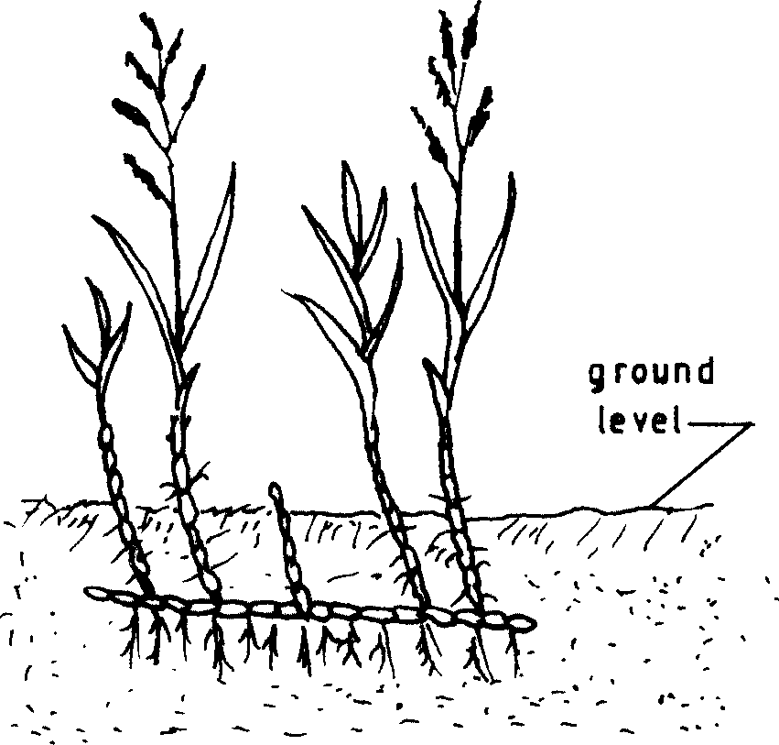Below is a diagram of a weed. Study the diagram carefully and answer the questions that follow.
   1. Identify the weed illustrated above. (1/2mk)

…………………………………………………………………………………………….

* 1. Why is the weed illustrated above difficult to control? (1mk)

………………………………………………………………………………………………

………………………………………………………………………………………………

……………………………………………………………………………………………..

* 1. State four ways in which the weed can be controlled in a field of maize.

(2mks)

………………………………………………………………………………………………

………………………………………………………………………………………………

………………………………………………………………………………………………

…………………………………………………………………………………………….

………………………………………………………………………………………………

………………………………………………………………………………………………

………………………………………………………………………………………………

……………………………………………………………………………………………

1. The diagram below shows a pest and the damaged crop. Study it and answer the questions that follow.

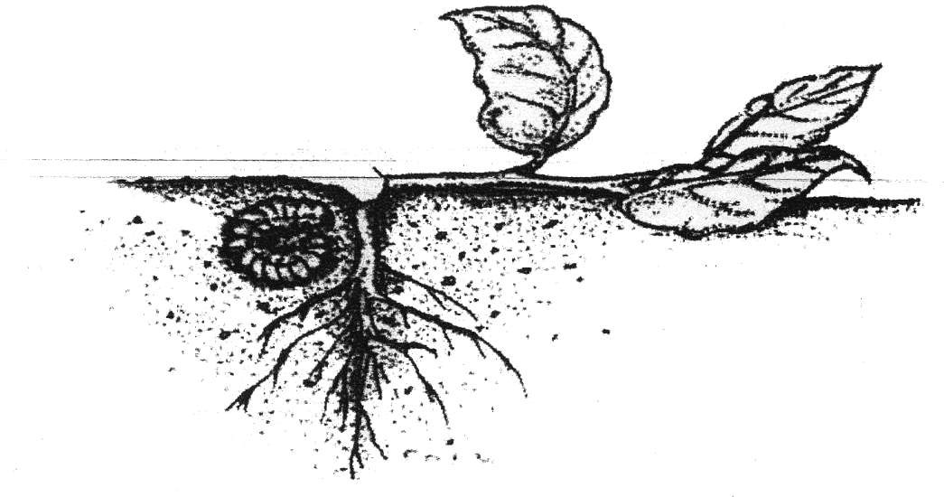

* 1. Identify the crop pest illustrated above. (1 mark)

………………………………………………………………………………………………

………………………………………………………………………………………………

* 1. Explain two ways of controlling the pests. (2 marks)

………………………………………………………………………………………

………………………………………………………………………………………………

………………………………………………………………………………………………

………………………………………………………………………………………………

1. The diagram below illustrates a nursery practice.

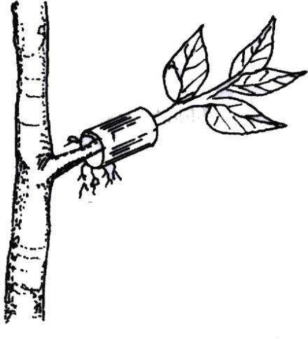

* 1. Identify the practice. **(1 mark)**

**…………………………………………………………………………**

**………………………………………………………………………..**

* 1. Describe the procedure followed in carrying out the practice illustrated.**(2 marks)**

……………………………………………………………………………………

……………………………………………………………………………………

……………………………………………………………………………………

……………………………………………………………………………………

…………………………………………………………………………………..

……………………………………………………………………………………

……………………………………………………………………………………

…………………………………………………………………………………

(c) State two advantages of the practice illustrated above in crop production.

**(2 marks)**

……………………………………………………………………………………

……………………………………………………………………………………

……………………………………………………………………………………

……………………………………………………………………………………

…………………………………………………………………………………….

……………………………………………………………………………………

……………………………………………………………………………………

……………………………………………………………………………………

……………………………………………………………………………………

b) State two ways in which pruning assists in controlling crop diseases. (1mk)

……………………………………………………………………………………

……………………………………………………………………………………

……………………………………………………………………………………

……………………………………………………………………………………

1. .The diagrams below illustrate field management practices. Study them carefully and answer the questions that follow.

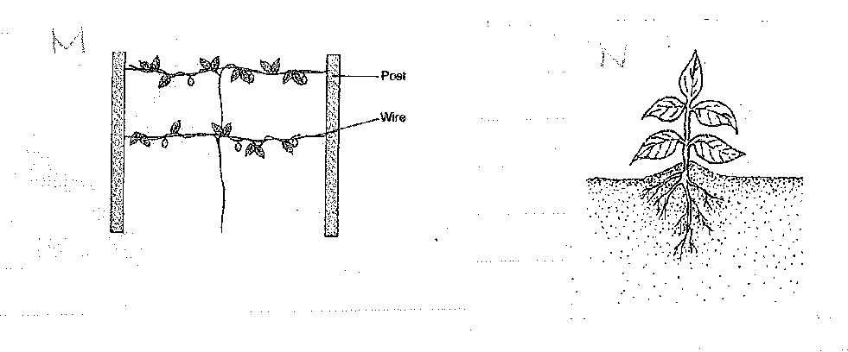

1. Identify the field practices.

M (1mk)

N (1mk)

1. Name a crop that can be managed using management (M) above.(1mk)

………………………………………………………………………………………………

………………………………………………………………………………………………

1. Give one reason for carrying out each of the management practices above.(2mks) M……………………………………………………………………………………

………………………………………………………………………………………

…………………………………………………………………………………….. N……………………………………………………………………………………

………………………………………………………………………………………

……………………………………………………………………………………..

1. A famer is advised to apply 60kg N, 20kg P2O5 and 30kg K2O per hectare. Calculate the quantity of urea (46%N), single super phosphate (20%P2O5) and muriate of potash (50% K2O) the farmer should apply on his 10 hectares land. **(5 mks)**

……………………………………………………………………………………

……………………………………………………………………………………

……………………………………………………………………………………

……………………………………………………………………………………

…………………………………………………………………………………….

……………………………………………………………………………………

……………………………………………………………………………………

……………………………………………………………………………………

……………………………………………………………………………………

***SECTION C (40 marks)***

***Answer any two questions in this section in the spaces provided after question 25.***

1. a) Explain eight factors that can encourage soil erosion. (8 mks)
2. Describe the seven management practices that should be carried out on a vegetable nursery after sowing seeds until the seedlings are ready for transplanting. (7 mks)
3. State five soil factors that should be considered when selecting a crop to grow in an area. (5mks)
4. a) Outline five ways in which high temperature affects agricultural production in Kenya. (5mks)
5. Describe five ways in which the following affects agriculture (7mks)
   1. poor economic growth
   2. poor health
6. Explain eight types of micro-catchments used in water conservation (8mks)
7. a) Explain six physical methods that can be used to control crop pests on the farm.

(6mks)

1. Describe SEVEN field management practices carried out in the production of tomatoes (7mks)
2. Explain seven factors that influence seed rates in crop production.

(7mks)

………………………………………………………………………………………………

…………………………………………………………………………………………

…………………………………………………………………………………………

…………………………………………………………………………………………

…………………………………………………………………………………………

…………………………………………………………………………………………..

…………………………………………………………………………………………

…………………………………………………………………………………………

…………………………………………………………………………………………

…………………………………………………………………………………………

…………………………………………………………………………………………

………………………………………………………………………………………..

…………………………………………………………………………………………

…………………………………………………………………………………………

…………………………………………………………………………………………

…………………………………………………………………………………………

…………………………………………………………………………………………

………………………………………………………………………………………..

…………………………………………………………………………………………

…………………………………………………………………………………………

…………………………………………………………………………………………

…………………………………………………………………………………………

…………………………………………………………………………………………

…………………………………………………………………………………………

…………………………………………………………………………………………

…………………………………………………………………………………………

…………………………………………………………………………………………

…………………………………………………………………………………………

…………………………………………………………………………………………

…………………………………………………………………………………………

…………………………………………………………………………………………

…………………………………………………………………………………………

…………………………………………………………………………………………

…………………………………………………………………………………………

…………………………………………………………………………………………

…………………………………………………………………………………………

…………………………………………………………………………………………

…………………………………………………………………………………………

…………………………………………………………………………………………

…………………………………………………………………………………………

…………………………………………………………………………………………

…………………………………………………………………………………………..

…………………………………………………………………………………………

…………………………………………………………………………………………

…………………………………………………………………………………………

…………………………………………………………………………………………

…………………………………………………………………………………………

…………………………………………………………………………………………

…………………………………………………………………………………………

…………………………………………………………………………………………

…………………………………………………………………………………………

…………………………………………………………………………………………

…………………………………………………………………………………………

…………………………………………………………………………………………

…………………………………………………………………………………………

…………………………………………………………………………………………

…………………………………………………………………………………………

…………………………………………………………………………………………

…………………………………………………………………………………………

…………………………………………………………………………………………

…………………………………………………………………………………………

…………………………………………………………………………………………

…………………………………………………………………………………………

…………………………………………………………………………………………

…………………………………………………………………………………………

…………………………………………………………………………………………

………………………………………………………………………………………………

…………………………………………………………………………………………

…………………………………………………………………………………………

…………………………………………………………………………………………

…………………………………………………………………………………………

………………………………………………………………………………………….

…………………………………………………………………………………………

…………………………………………………………………………………………

…………………………………………………………………………………………

…………………………………………………………………………………………

…………………………………………………………………………………………

…………………………………………………………………………………………..

………………………………………………………………………………………………

…………………………………………………………………………………………

…………………………………………………………………………………………

…………………………………………………………………………………………

…………………………………………………………………………………………

……………………………………………………………………………………….

…………………………………………………………………………………………

…………………………………………………………………………………………

…………………………………………………………………………………………

…………………………………………………………………………………………

…………………………………………………………………………………………

…………………………………………………………………………………………

……………………………………………………………………………………….



END